**Competition on Black-box Consensus-based Distributed Optimization**

1. **Descriptions of the problem**

Consensus-based Distributed optimization (CDO) is a common problem definition for optimization problems in networked systems. Usually, a networked system contains multiple physical or virtual entities, which are termed nodes or agents. In CDO, there is a local objective function for each node, and the systematic objective function, i.e. global objective function, is the sum of all local objective functions. CDO aims to minimize the global objective function and make the nodes reach a consensus on the final solution. There are two major features of CDO, limited local information and no-center local communication. First, each node can only access its own local objective function. This is because the local objective function is usually related to the privacy data, real-time data, or mass data stored in terminal devices, which cannot be transmitted to other nodes. What's more, the local objective functions of different nodes are usually conflicting to some extent. Second, the communication network of CDO is usually a not-fully-connected graph without a center node. Nodes can only communicate with immediate neighbors in the graph.

1. **Motivations and expected impact on evolutionary computation**

The goal of the competition is to encourage participants to use zero-order optimization algorithms such as evolutionary computation to improve performance of black-box CDO. To this end, we design a set of benchmark functions for black-box consensus-based distributed optimization. This benchmark set considers different communication environments, conflict degrees, node homogeneity, and types of objective functions. The main rule of this competition is to find the best possible global solution under the specified number of evaluations, while taking into account the consensus of the system and the communication efficiency. This competition is promising to encourage more related research and extend the application of evolutionary computation to real-world distributed and multi-agent systems.

1. **Data description**

The competition provides an algorithm development platform for DCO. This platform provides interfaces for evaluation functions, communication, and performance evaluation, allowing developers to focus only on algorithm design. First, we design 5 groups of 36 benchmark functions in total for black-box and non-convex DCO, and provide evaluation interfaces for these functions. Besides, this competition considers a real-world application, the multi-target localization problem in wireless sensor networks. Second, we provide peer-to-peer communication interfaces based on the communication topology of benchmark functions. These interfaces confirm that each node can only communicate with immediate neighbors. Third, we provide the performance evaluation interface for algorithms, including solution quality, communication efficiency, and system consensus. Framework, benchmark, and data are available in:

https://github.com/iamrice/Proposal-for-Competition-on-Black-box-and-Non-convex-Distributed-Consensus-Optimization

1. **Evaluation procedures and established baselines**

All the submitted entries will be evaluated on our platform by the following evaluation procedures:

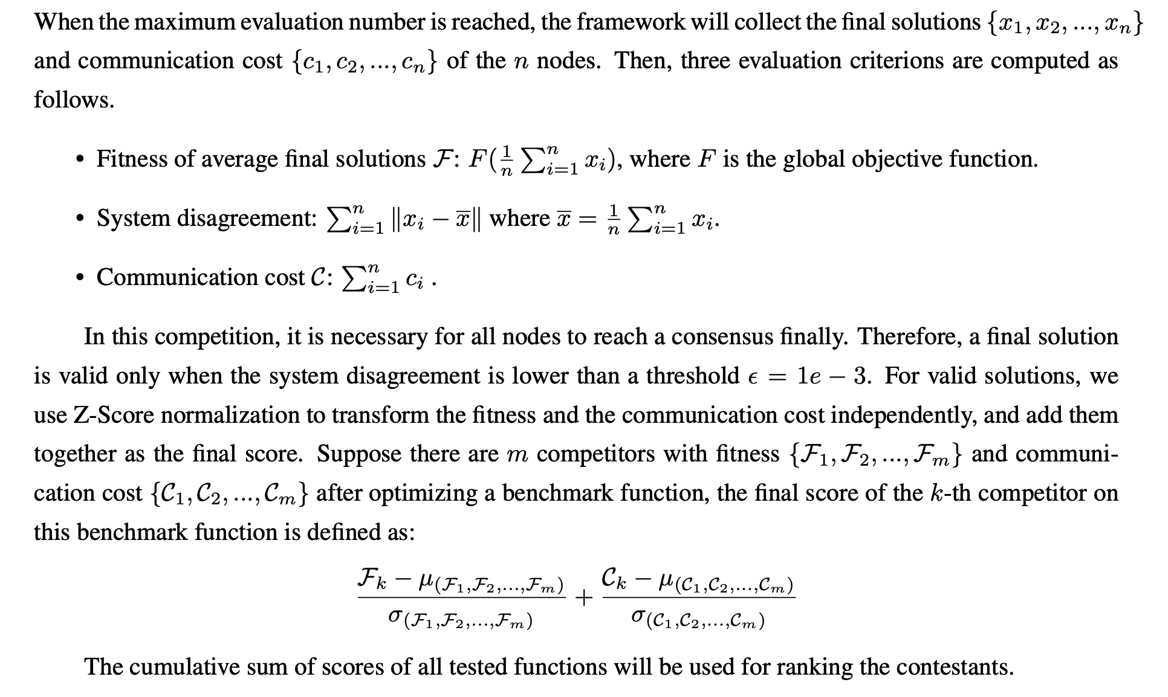

1. **Schedules**

submission deadline: May 8, 2025

Notification (final ranking): June 8, 2025

1. **Anticipated number of participants**

10~100 participants.

1. **Biography of the main team members**

**Wei-Neng Chen** (Senior Member, IEEE)

South China University of Technology, China.

Email: [cschenwn@scut.edu.cn](mailto:cschenwn@scut.edu.cn)

**Wei-Neng Chen** received the bachelor’s and Ph.D. degrees in computer science from Sun Yat-sen University, Guangzhou, China, in 2006 and 2012, respectively. Since 2016, he has been a Full Professor with the School of Computer Science and Engineering, South China University of Technology, Guangzhou. He has coauthored over 100 international journal and conference papers, including more than 70 papers published in the IEEE TRANSACTIONS journals. His current research interests include computational intelligence, swarm intelligence, network science, and their applications. Dr. Chen was a recipient of the IEEE Computational Intelligence Society Outstanding Dissertation Award in 2016 and the National Science Fund for Excellent Young Scholars in 2016. He was also a Principle Investigator of the National Science and Technology Innovation 2030—the Next Generation Artificial Intelligence Key Project. He is currently the Vice-Chair of the IEEE Guangzhou Section, and the Chair of IEEE SMC Society Guangzhou Chapter. He is also a Committee Member of the IEEE CIS Emerging Topics Task Force. He serves as an Associate Editor for the IEEE TRANSACTIONS ON NEURAL NETWORKS AND LEARNING SYSTEMS and the Complex and Intelligent Systems.

**Tai-You Chen** (Student Member, IEEE)

South China University of Technology, China.

Email: [cstaiutan@mail.scut.edu.cn](mailto:cstaiutan@mail.scut.edu.cn)

**Tai-You Chen** received the bachelor’s degree in computer science and technology from the South China University of Technology, Guangzhou, China, in 2022, where he is currently pursuing the Ph.D. degree in computer science and technology with the School of Computer Science and Engineering. His current research interests include swarm intelligence, evolutionary computation, distributed consensus optimization, multi-agent systems, and their applications in real-world problems.

**Feng-Feng Wei** (Student Member, IEEE)

South China University of Technology, China.

Email: [fengfeng_scut@163.com](mailto:fengfeng_scut@163.com)

**Feng-Feng Wei** received the bachelor’s degree in computer science and technology from the South China University of Technology, Guangzhou, China, in 2019, where she is currently pursuing the Ph.D. degree in computer science and technology with the School of Computer Science and Engineering and the State Key Laboratory of Subtropical Building and Urban Science. Her current research interests include swarm intelligence, evolutionary computation, distributed optimization, edge–cloud computing, and their applications on expensive optimization in real-world problems.